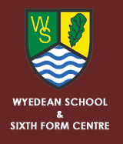

WY2
Lydney, Bus Station | 0800
Lydney, Tesco | 0802
Lydney, Cross | 0803
Aylburton, Common Turn | 0805
Alvington, Opp The Globe | 0808
Woolaston, Opp Inn | 0810
Wyedean Arrive | 0820
Wyedean School Depart | 1530
Woolaston, Inn | 1539
Alvington, The Globe | 1541
Aylburton, Common Turn | 1544
Lydney, Opp Town Hall | 1546
Lydney, Opp Tesco | 1548
Lydney, Bus Station | 1550

